Using iPads to Increase Student Engagement
Sherry Graham
November 22, 2014
Sherri Booker
Fall 2012

Setting/Context
The Using iPads to Increase Student Engagement project will take place at Powder Springs Elementary during the course of the 2013-2014 school year. Powder Springs is a school in Cobb County School District that serves students in pre-kindergarten through fifth grade. The school is situated in a suburban setting with a school population of approximately 800 students and 75% of students are eligible for free and reduced lunches. Powder Springs Elementary is a Title I school. Title I is a federally funded program that provides services to schools based on student economic needs. The stakeholders affected by the project include staff, students and families of students at Powder Springs Elementary. The focus of the project is on improving student engagement through the use of iPads in the elementary classroom, which has a direct effect on all stakeholders. Teachers will receive professional development to improve instructional practice, students will be met where their needs lie, and families will see improvements in their children’s engagement in academics.
Capstone Problem and Rationale
Technology is a vital component in educating students of today to be leaders of tomorrow. Powder Springs Elementary focuses its efforts on providing students with an educational foundation that develops students into well-rounded individuals. In order to facilitate high quality, student-centered learning, students must have access to devices that transfer best practices into reality. Students in the current generation rely on technology for communication, daily living, and entertainment. This is the primary foundation that can shape instructional practice at all levels. Teachers in Cobb County are equipped with a variety of technological resources, having access to three classroom computers, a projector, an interactive white board, and a printer on a daily basis. Software to support learning content is available as well as wireless access to the Internet. During the 2013-2014 school year, Powder Springs Elementary has been making progress in increasing access to current, emerging technologies and digital resources. The school recently utilized Title I funds to purchase two carts containing thirty iPads each for primary and intermediate grade levels. Access to technology is increasing within classrooms at Powder Springs Elementary and teachers are seeking ways to integrate technology effectively into their curriculum. Classroom observations have determined that teachers are not designing learning activities that require students to use higher level thinking skills and showcase their creativity, nor are they taking advantage of the latest Web 2.0 tools to strengthen curriculum.
According to Creighton (2003), the purpose of effective technology integration is “how the teacher uses technology to support clear learning objectives” (p. 68). While the integration of technology in schools involves the actual use of technology tools like interactive whiteboards, tablet devices and computers, teachers must use best practices on a daily basis to challenge, invigorate and motivate learners. Oftentimes when technology is effectively integrated into a classroom, it is within a setting where these routine practices are in place. Combined with clear learning objectives and outcomes, the foundation of effective education requires the same principles as effective technology integration (Creighton, 2003). As technology becomes more prevalent and plentiful in classrooms at Powder Springs Elementary with iPads, teachers need to evaluate how they use the tools to facilitate student driven learning and begin creating twenty-first century classrooms.
Student engagement is vital to effective learning. As noted by Mehdinezhad (2011), student engagement in activities contributes to their learning achievements and their sense of belonging to the academic community. William Beeland, Jr. (2002) has similar conclusions, stating, “Student engagement is one of most important factors that affect teaching and student motivation to learn” (p.1). Beeland (2002) emphasizes the influence that motivation plays in the learning process, “The more students are motivated to learn, the more likely it is that they will be successful in their efforts” (p.2). It is vital that students stay involved in their academic learning. Teachers should actively implement best practices in education to support student-centered learning. Educators must be informed on proper technology integration techniques to ensure optimal student learning using accessible digital tools. Based upon Val Mehdinezhad’s (2011) research, evidence supports the fact that the effective use of technology in education requires an informed understanding of the expectations of students, staff and institutions. It requires a “preparation for and induction into the use of technology to foster positive learning and student outcomes” (Mehdinezhad, 2011, p. 52). There is a definite need for professional development to increase student engagement and teacher competency at Powder Springs Elementary.
Objectives
- Increase student learning and engagement through the use of the emerging technology, iPads, at Powder Springs Elementary.
- Determine the effect the use of iPads has as an instructional tool on student engagement.
- Respond to the need for professional development in the area of technology by teaching teachers how to empower students to use technology to reach higher levels of learning and engagement.
- Provide staff with training and resources to give them the opportunity to create, explore, and extend their knowledge using the iPad, promoting use of the tool to support student-centered learning.
Deliverables
- Six Using iPads to Increase Student Engagement training sessions for teachers participating in the project.
- Six Power Point Presentations to guide the learning sessions.
- Using iPads to Increase Student Engagement website will be created for Powder Springs Elementary educators. It will include supplemental resources as well as lesson ideas to further professional learning and enhance participants’ teaching practices.
PSC Standards
- Standard 1. Visionary Leadership: Candidates demonstrate the knowledge, skills, and dispositions to inspire and lead the development and implementation of a shared vision for the effective use of technology to promote excellence and support transformational change throughout the organization.
  - Element 1.1 Shared Vision: Candidates facilitate the development and implementation of a shared vision for the use of technology in teaching, learning, and leadership. (PSC 1.1/ISTE 1a)
  - Element 1.4 Diffusion of Innovations & Change: Candidates research, recommend, and implement strategies for initiating and sustaining technology innovations and for managing the change process in schools. (PSC 1.4/ISTE 1d)
- Standard 2. Teaching, Learning, & Assessment: Candidates demonstrate the knowledge, skills, and dispositions to effectively integrate technology into their own teaching practice and to collaboratively plan with and assist other educators in utilizing technology to improve teaching, learning, and assessment.
  - Element 2.1 Content Standards & Student Technology Standards: Candidates model and facilitate the design and implementation of technology-enhanced learning experiences aligned with student content standards and student technology standards. (PSC 2.1/ISTE 2a)
  - Element 2.2 Research-Based Learner-Centered Strategies: Candidates model and facilitate the use of research-based, learner-centered strategies addressing the diversity of all students. (PSC 2.2/ISTE 2b)
  - Element 2.3 Authentic Learning: Candidates model and facilitate the use of digital tools and resources to engage students in authentic learning experiences. (PSC 2.3/ISTE 2c)
  - Element 2.4 Higher Order Thinking Skills: Candidates model and facilitate the effective use of digital tools and resources to support and enhance higher order thinking skills (e.g., analyze, evaluate, and create); processes (e.g., problem-solving, decision-making); and mental habits of mind (e.g., critical thinking, creative thinking, metacognition, self-regulation, and reflection). (PSC 2.4/ISTE 2d)
  - Element 2.6 Instructional Design: Candidates model and facilitate the effective use of research-based best practices in instructional design when designing and developing digital tools, resources, and technology-enhanced learning experiences. (PSC 2.6/ISTE 2f)
- Standard 3. Digital Learning Environments: Candidates demonstrate the knowledge, skills, and dispositions to create, support, and manage effective digital learning environments.
  - Element 3.1 Classroom Management & Collaborative Learning: Candidates model and facilitate effective classroom management and collaborative learning strategies to maximize teacher and student use of digital tools and resources. (PSC 3.1/ISTE 3a)
  - Element 3.6 Selecting and Evaluating Digital Tools & Resources: Candidates collaborate with teachers and administrators to select and evaluate digital tools and resources for accuracy, suitability, and compatibility with the school technology infrastructure. (PSC 3.6/ISTE 3f)
  - Element 3.7 Communication & Collaboration: Candidates utilize digital communication and collaboration tools to communicate locally and globally with students, parents, peers, and the larger community. (PSC 3.7/ISTE 3g)
- Standard 4. Digital Citizenship & Responsibility: Candidates demonstrate the knowledge, skills, and dispositions to model and promote digital citizenship and responsibility.
  - Element 4.1 Digital Equity: Candidates model and promote strategies for achieving equitable access to digital tools and resources and technology-related best practices for all students and teachers. (PSC 4.1/ISTE 5a
  - Element 4.2 Safe, Healthy, Legal & Ethical Use: Candidates model and facilitate the safe, healthy, legal, and ethical uses of digital information and technologies. (PSC 4.2/ISTE 5b)
- Standard 5. Professional Learning & Program Evaluation: Candidates demonstrate the knowledge, skills, and dispositions to conduct needs assessments, develop technology-based professional learning programs, and design and implement regular and rigorous program evaluations to assess effectiveness and impact on student learning.
  - Element 5.1 Needs Assessment: Candidates conduct needs assessments to determine school-wide, faculty, grade-level, and subject area strengths and weaknesses to inform the content and delivery of technology-based professional learning programs. (PSC 5.1/ISTE 4a)
  - Element 5.2 Professional Learning: Candidates develop and implement technology-based professional learning that aligns to state and national professional learning standards, integrates technology to support face-to-face and online components, models principles of adult learning, and promotes best practices in teaching, learning, and assessment. (PSC 5.2/ISTE 4b)
Project Description
- Narrative
The purpose of the capstone project is to help teachers develop awareness and competency in utilizing digital learning tools in their classroom. Due to the fact that iPads are a new technology at Powder Springs for the 2013-2014 school year, the decision was made to implement a series of professional development sessions that aim to increase teacher competency in using iPads in the classroom. Teachers expressing interest in utilizing the iPad carts are expected to attend training sessions to properly implement them in their classrooms.
The series of professional development sessions will begin with the general concept of effective technology integration and evolve into weekly sessions that will include training on iPad applications that teachers can integrate into curriculum. Emphasis will be placed on encouraging teachers to facilitate student-centered learning, focusing on engagement, communication and critical thinking. Teachers will learn how to create challenges and opportunities for students to use tools to accomplish tasks or to solve problems. They will learn how to write lessons that do more than merely integrate technology, but embed it into their teaching. Teachers will be required to apply tasks during training sessions to ensure application of knowledge. Guidance and scaffolding will be provided during sessions to ensure teachers have levels of appropriate support. They will be given the opportunity to reflect and communicate findings.
In addition to the professional development sessions, a portion of the capstone project will involve the creation of a website for teachers to utilize that includes digital learning tools and resources that can help guide teachers develop lessons as they apply knowledge gained in learning sessions. The core components for the website will include professional learning resources and iPad management tips. The professional learning resources will include links to lesson ideas, web resources, and PowerPoints used during learning sessions. Within these resources, emphasis will be placed on providing teachers with additional support in facilitating a 21st Century Classroom, the topic of project based learning, and include lesson ideas. There will be a section that houses resources and tips to launch the use of the iPad in the elementary classroom. This will give teachers the opportunity to explore topics on their own time at their own pace.
Student engagement will be examined in a class of students who do not have access to iPads prior to professional development sessions. Student participants will consist of members of a classroom of a teacher who will attend the training sessions. Engagement in this class will be measured through obtaining opinions of students on the topic of utilizing iPads as a learning tool. Teachers as well as students will complete a pre and post-survey to assess their knowledge on the integration of iPads into curriculum and its effect on student engagement while learning (See Appendix A & Appendix B).
- Timeline
The timeline of trainings will occur weekly during the second semester of school and sessions will occur from 2:45-4:00 on Thursdays. There will be six learning sessions that train teachers on effective technology integration in the classroom. Non-mandatory work sessions will be scheduled as necessary and will be based on need. The tentative dates are as follows:
November 2, 2013 | Create/issue survey to participants and gather data
November 2013- March 2014 | Create website (continuously update)
January 16, 2014 | Training Session 1
January 23, 2014 | Training Session 2
January 30, 2014 | Training Session 3
February 6, 2014 | Training Session 4
February 27, 2014 | Training Session 5
March 6, 2014 | Training Session 6
March 6, 2014 | Issue follow-up survey to participants to gather data to evaluate project
- Resources
The project will require multiple resources to execute which will be secured by communicating with the Assistant Principal and Media Specialist at Powder Springs Elementary. They are listed as follows:
- Space
  - Media Center for each learning session
- Materials
  - iPad cart
  - iPad check out schedule
  - Laptop
  - Wireless internet access
  - Projector/ SmartBoard
  - Weebly Account
- Human Resources
  - Media Specialist (for application downloads)
  - Class of students (whose teacher is receiving the training)
Evaluation Plan
The overall objective of the capstone project is to increase staff learning and student engagement through the use of iPads at Powder Springs Elementary. To show that objectives have been met, an evaluation will occur in the form of a survey that assesses the effectiveness of trainings in both a quantitative and qualitative method of study. Data will be retrieved from teacher participants to measure if objectives were met (See Appendix A). Student engagement and motivation to learn will be measured based on a survey modified from William Beeland, Jr.’s study on student engagement (2002). Students will be administered a survey utilizing GoogleForms to evaluate their attitude towards using iPads in the classroom (See Appendix B). The data from the surveys will be analyzed and compared to the baseline data. This information will measure the success of the project. This information will measure the success of the professional learning sessions and show whether or not objectives were met.
The objectives and evaluation techniques relate because the objectives are concrete and interrelated. Staff members will be trained to use best practices in their classroom and meet students where their needs lie. Teachers will evaluate how their teaching practices have evolved and how student engagement and motivation have increased as a result of the implementation of the digital learning tools. Students will share their learning thoughts and their engagement towards academics will be assessed.
The timeline for each training session’s evaluation is outlined in the project description timeline. The pre surveys will be sent out on November 2, 2013 and the post surveys will be sent out on March 6, 2014. Based on the survey results and interest level of the staff, Professional Development sessions will be developed for the 2014-2015 school year.

References
Beeland, W. D. (2002, July). Student engagement, visual learning and technology: Can interactive whiteboards help? In Annual Conference of the Association of Information Technology for Teaching Education.
Creighton, T. (2003). The principal as a technology leader. Thousand Oaks, CA: Sage, Chapters 1-4, pp. 1-41.
Mehdinezhad, V. (2011). First year students' engagement at the university. International Online Journal of Educational Sciences, 3(1), 47-66.

Appendix A
Staff Survey
https://docs.google.com/forms/d/10_yTEU_MM2WpIYggVKr5dTz3Q2TUrEcAkSakSYMBJ2s/viewform

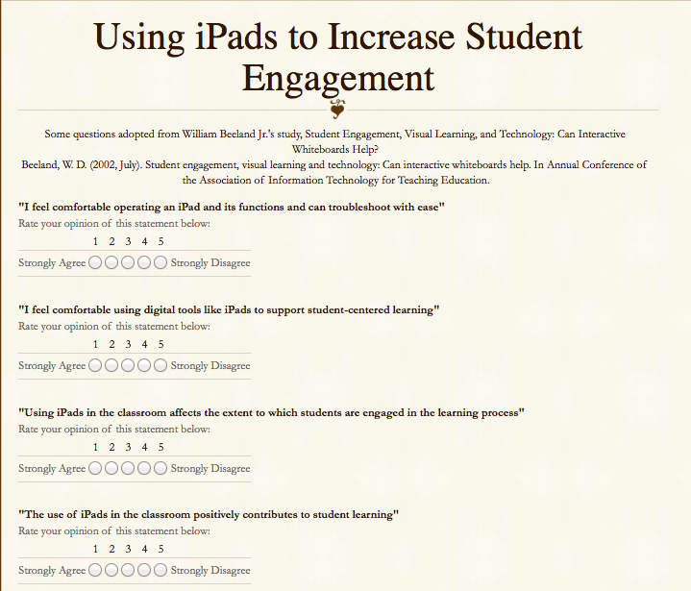
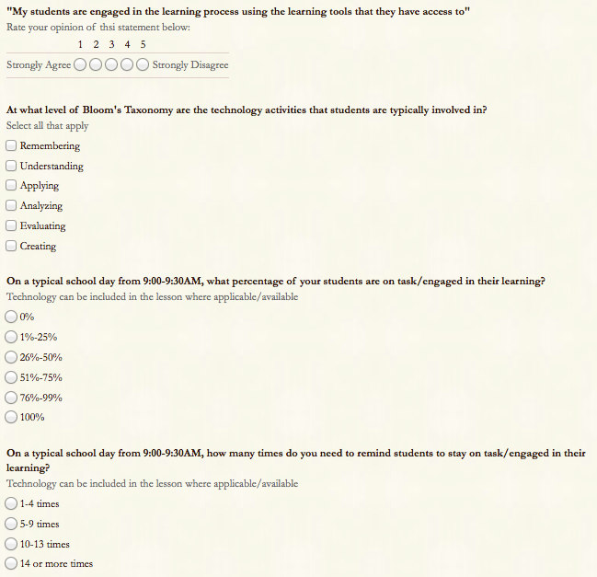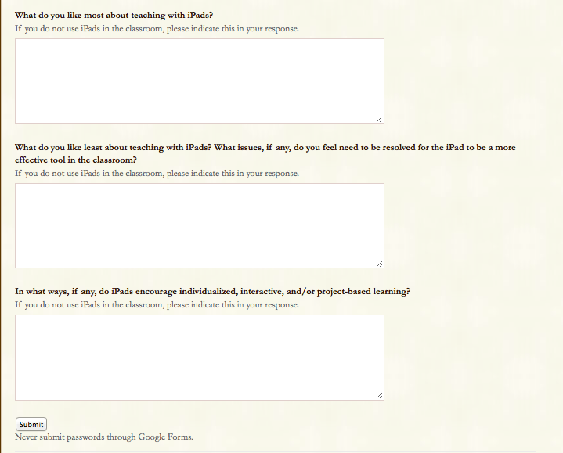

Appendix B
Student Survey
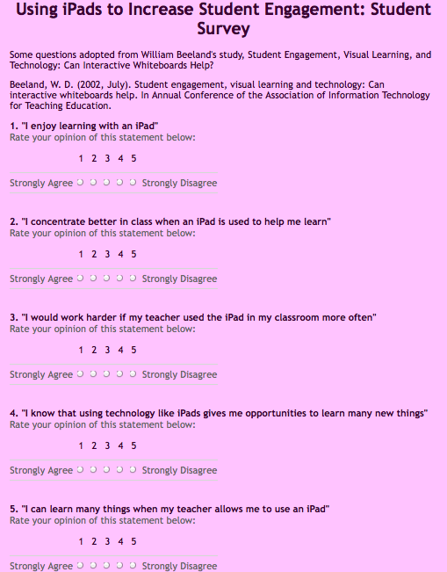
https://docs.google.com/forms/d/1S1hEcmHhtFvlJ2CuPUC9BR4xk9AxSaNWVhmLRYb6KTI/viewform
